File Manager API Documentation response screenshots.

Base URL
{{URL}}

Authentication
All APIs require an Authorization token.

Header
Authorization: Bearer <TOKEN>
Content-Type: application/json

Available Tokens
Token | Description
{{TOKEN}} | Client/Admin Access
{{CP_TOKEN}} | Creative Partner (CP) Access

Workflow Summary
Client
│
└── Upload files in Pre-Production
│
▼
CP
└── Upload Raw Footage in Post-Production
│
▼
Client
└── Select files for edits
│
└── Selected For Edits ( Email to CP & Admin )
▼
CP
└── Create Version1
└── Upload edited files
│
└── Email to Client & Admin
▼
Client Review
│
├── Approve
│ ▼
│ Final Deliverables
│
└── Request Revision
│
└── Email to CP & Admin
▼
CP
└── Create Version2
└── Upload revised files
│
▼
Client Review Again
│
├── Approve → Final Deliverables
└── Request Revision → Next Version

Project Folder Structure
Project Root
│
├── Pre-Production
│
└── Post-Production
├── Raw Footage
├── Edits
│ ├── Selected for Edits
│ └── Revisions
│ ├── Version1
│ ├── Version2
│ └── ...
└── Final Deliverables

1. Get All Project Workspaces
Returns all available project workspaces.

Endpoint
GET /external-file-manager/workspaces

Headers
Authorization: {{CP_TOKEN}}

Example
GET {{URL}}external-file-manager/workspaces
CP App Res:
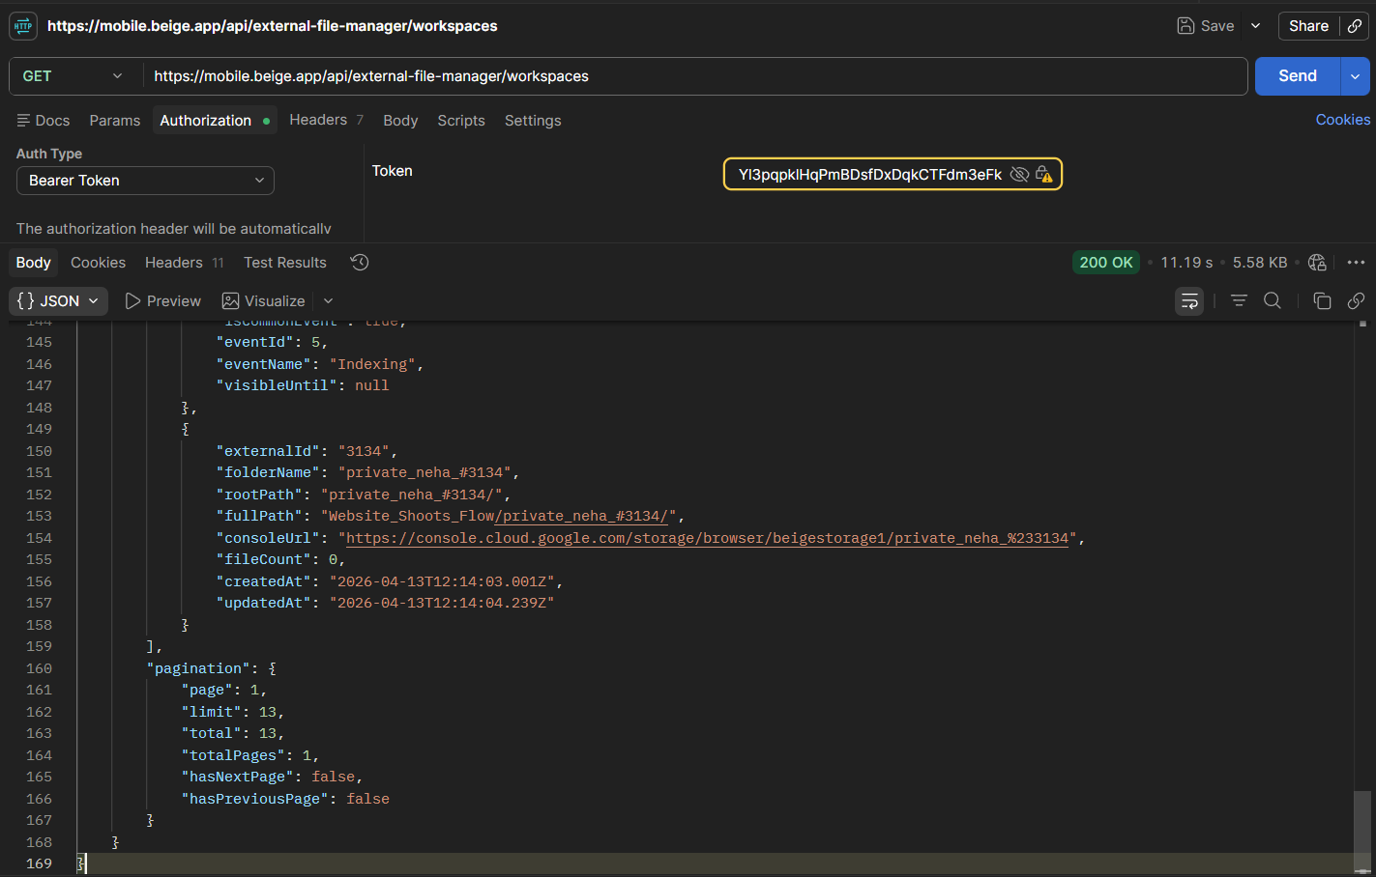
CP Web Res:
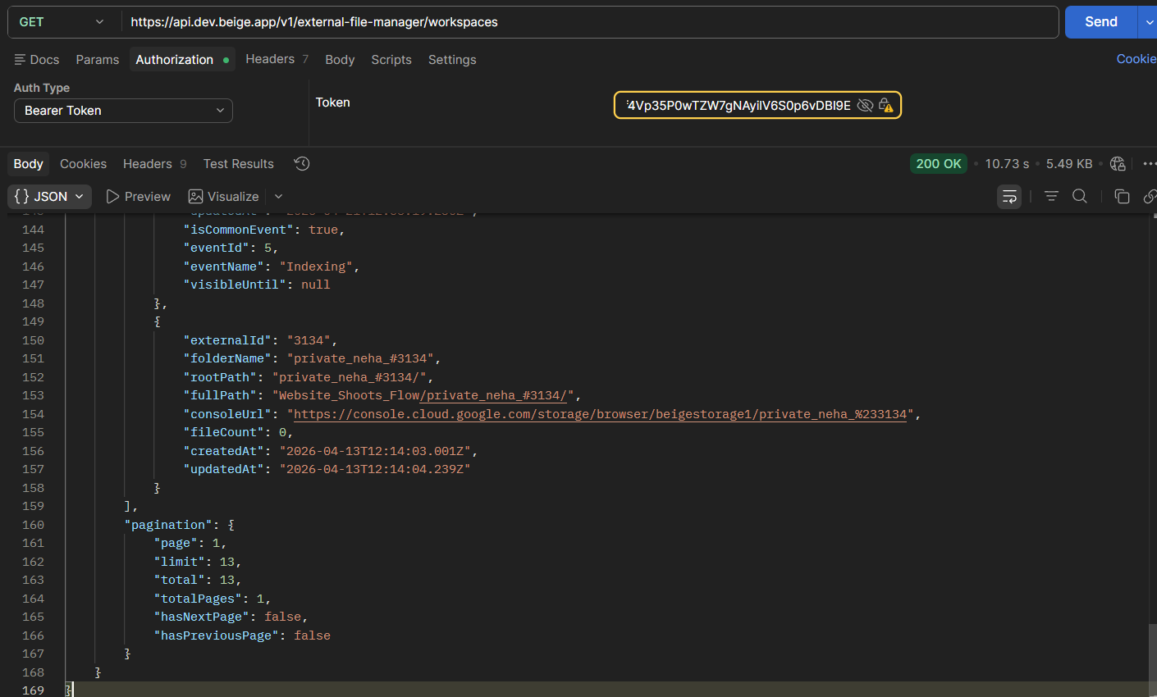
User App Res:
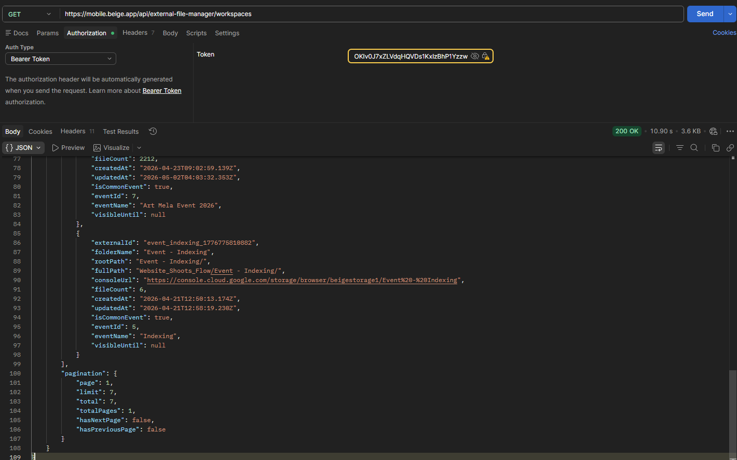

User Web Res:
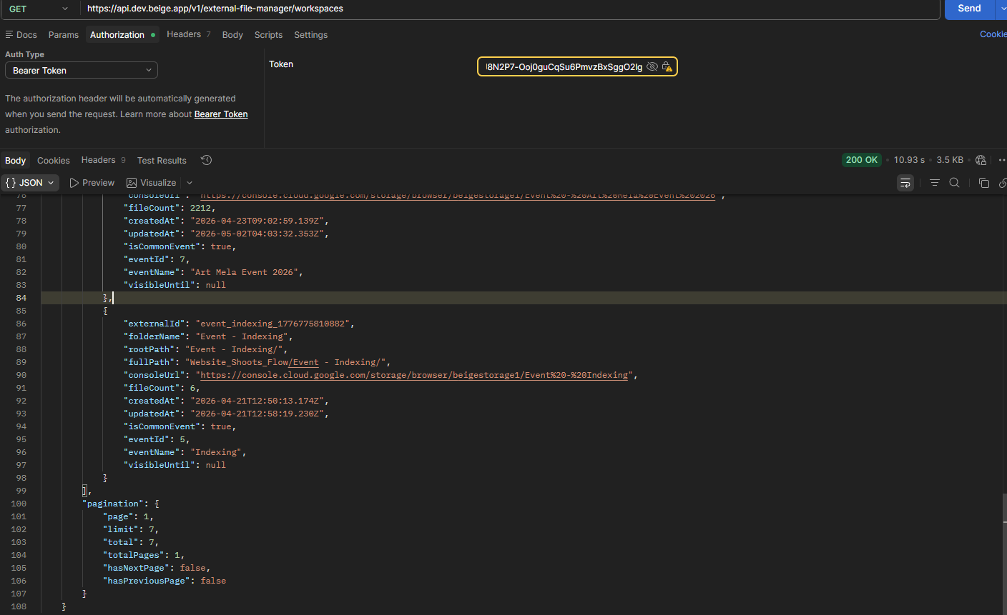

2. Get Workspace By External ID
Returns details of a specific project workspace.

Endpoint
GET /external-file-manager/workspace/{externalId}

Path Parameters
Parameter | Type | Required | Description
externalId | String | Yes | Booking external ID

Example
GET {{URL}}external-file-manager/workspace/1269

User App Res:
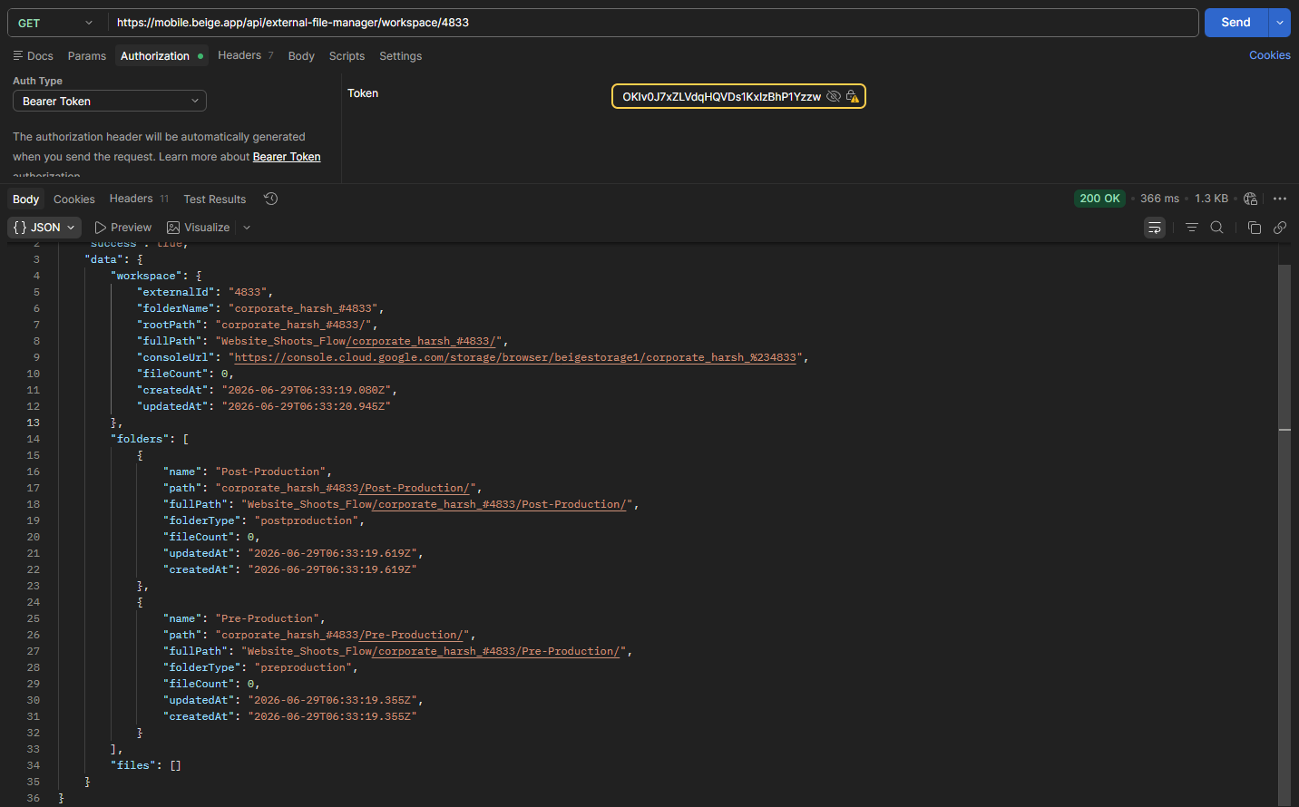
User Web Res:
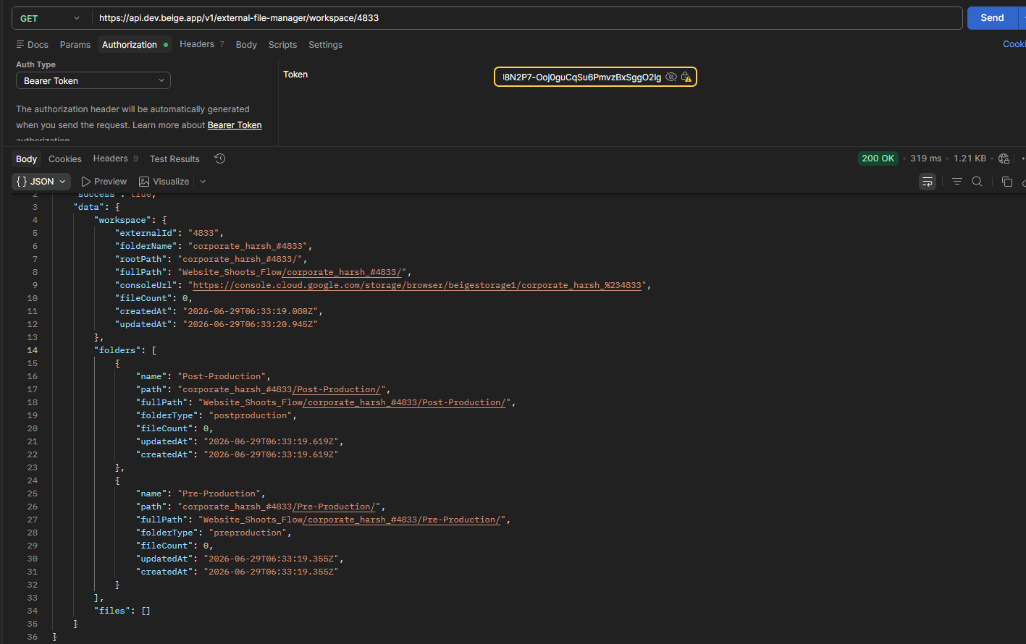

3. Open Folder Contents
Returns files and folders inside a project directory.

Endpoint
GET /external-file-manager/workspace/{externalId}/files

App Res:
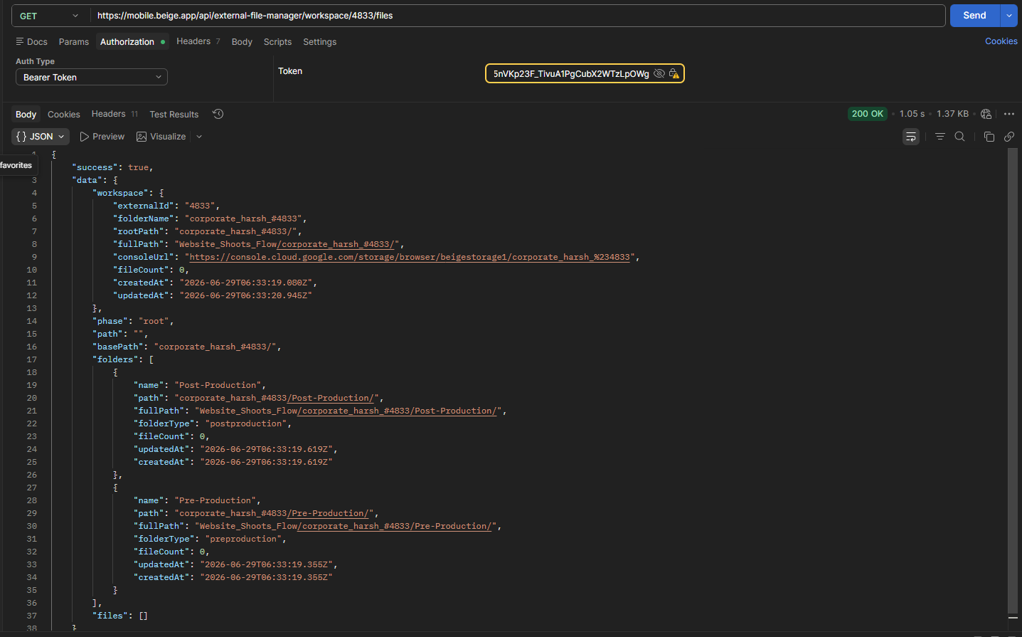

Web Res:
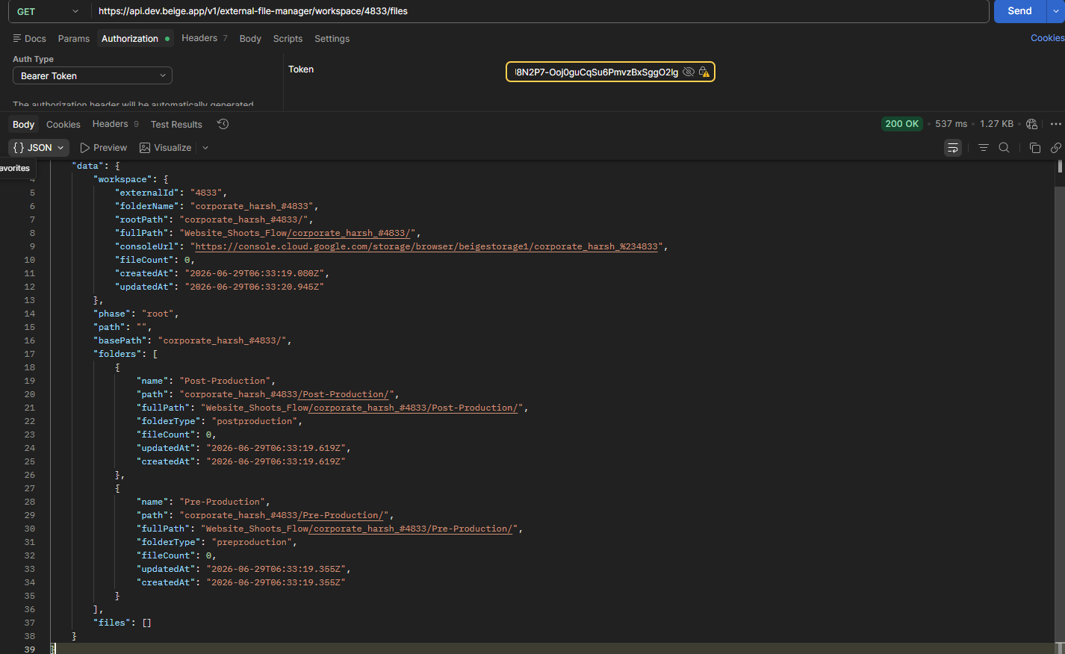

Query Parameters
Parameter | Type | Required | Description
phase | String | Yes | pre or post
path | String | No | Folder path

Open Pre-Production
GET {{URL}}external-file-manager/workspace/1273/files?phase=pre

Open Post-Production
GET {{URL}}external-file-manager/workspace/1273/files?phase=post

Open Edits Folder
GET {{URL}}external-file-manager/workspace/1273/files?phase=post&path=Edits

Open Revisions Folder
GET {{URL}}external-file-manager/workspace/1273/files?phase=post&path=Edits/Revisions

Open Selected For Edits
GET {{URL}}external-file-manager/workspace/1273/files?phase=post&path=Edits/Selected for Edits

Open Raw Footage
GET {{URL}}external-file-manager/workspace/1273/files?phase=post&path=Raw Footage

Open Final Deliverables
GET {{URL}}external-file-manager/workspace/1273/files?phase=post&path=Final Deliverables

4. Download Folder
Generates a downloadable URL for an entire folder.

Endpoint
POST /external-file-manager/folder-download-url

Download Project Root

Request
{
"externalId": "1273"
}
App Res:
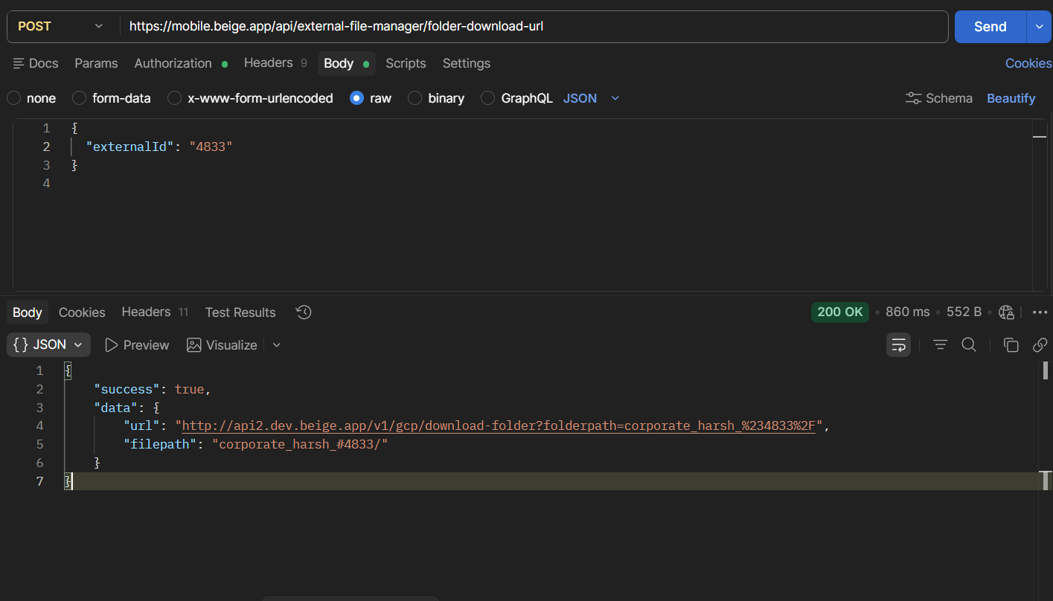

Web Res:
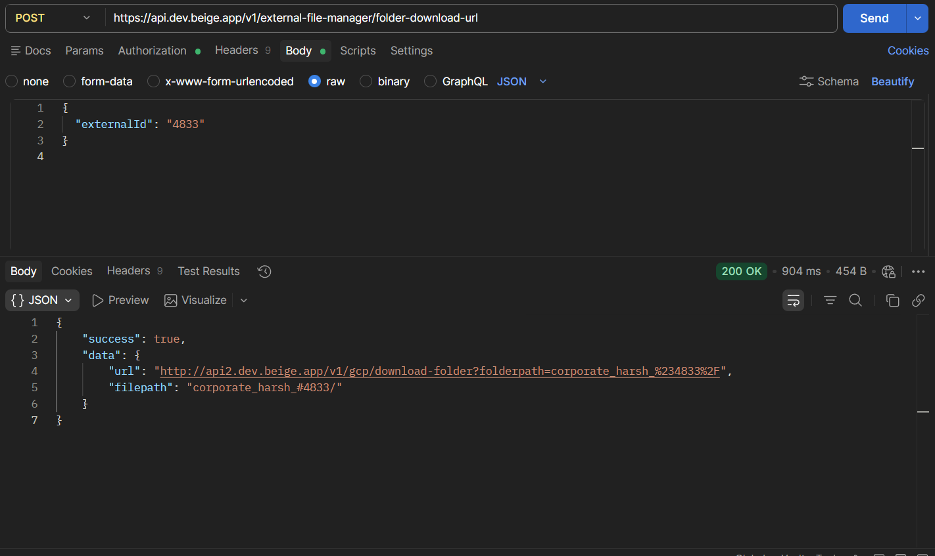

Download Pre-Production

Request
{
"externalId": "1273",
"phase": "pre"
}

Download Post-Production

Request
{
"externalId": "1273",
"phase": "post"
}

Download Specific Folder

Request
{
"externalId": "1273",
"phase": "post",
"path": "Edits"
}

5. Create Folder
Creates a new folder inside Pre-Production or Post-Production.

Endpoint
POST /external-file-manager/folder
App Res:
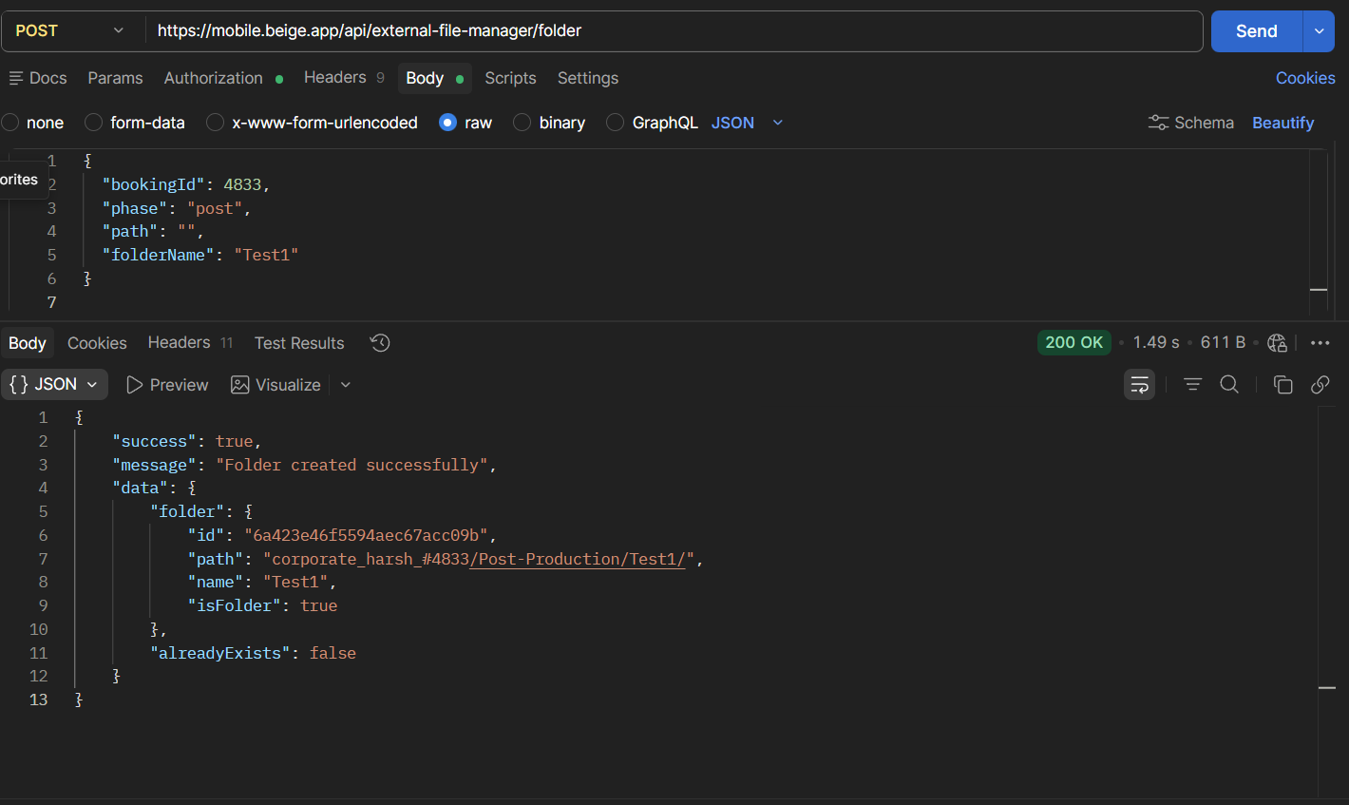

Web Res:
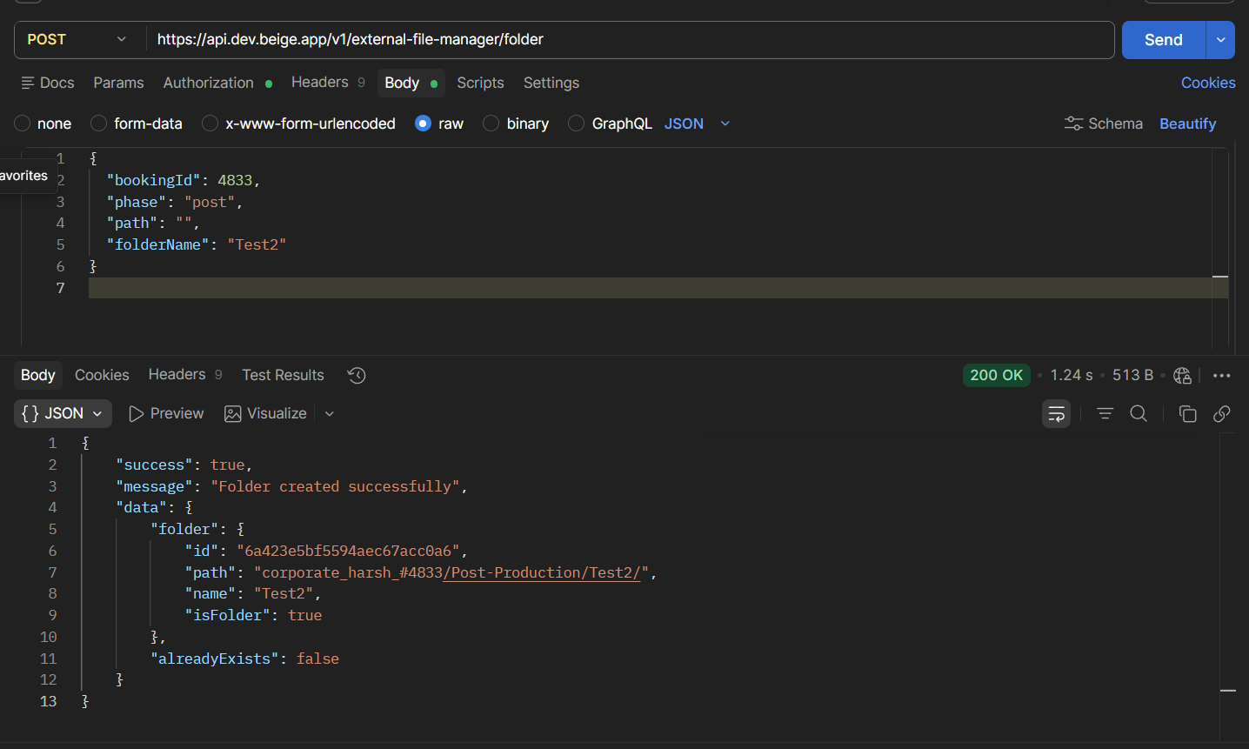

Request Body
Field | Type | Required | Description
bookingId | Number | Yes | Booking ID
phase | String | Yes | pre or post
path | String | No | Parent folder
folderName | String | Yes | Folder name

Create Root Folder
{
"bookingId": 934,
"phase": "post",
"path": "",
"folderName": "David"
}

Create Nested Folder
{
"bookingId": 934,
"phase": "post",
"path": "David",
"folderName": "New"
}

6. Upload Files
Generates upload policies for files.

Endpoint
POST /external-file-manager/upload-policies/batch

Request Body
{
"items": [
{
"filepath": "corporate_neha_#1273/Post-Production/Raw Footage/5.jpeg",
"fileContentType": "image/jpeg",
"fileSize": 271606
}
]
}

Fields
Field | Description
filepath | Complete destination path
fileContentType | MIME type
fileSize | File size in bytes

7. Mark Files Uploaded

Endpoint
POST /external-file-manager/files-uploaded/batch

Request
{
"items": [
{
"filepath": "social_content_neha_#1004/Post-Production/Raw Footage/4.jpeg",
"fileContentType": "image/jpeg",
"fileSize": 271606,
"fileName": "4.jpeg"
}
]
}

8. View File
Returns a signed URL for viewing a file.

Endpoint
POST /external-file-manager/file-view-url

Request
{
"filepath": "corporate_neha_#1273/Post-Production/Edits/Revisions/Version1/5.jpeg"
}
App Res:
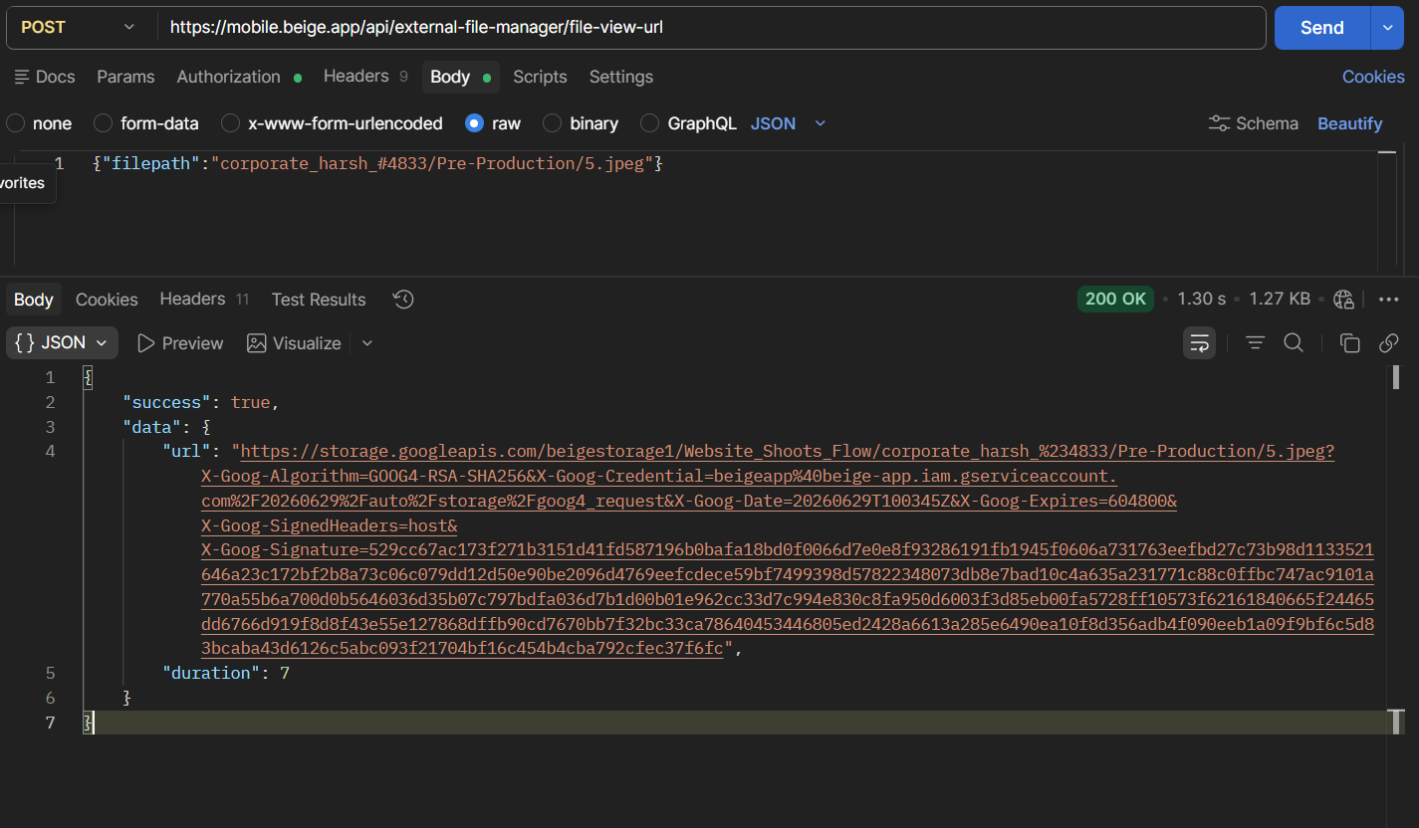
Web Res:
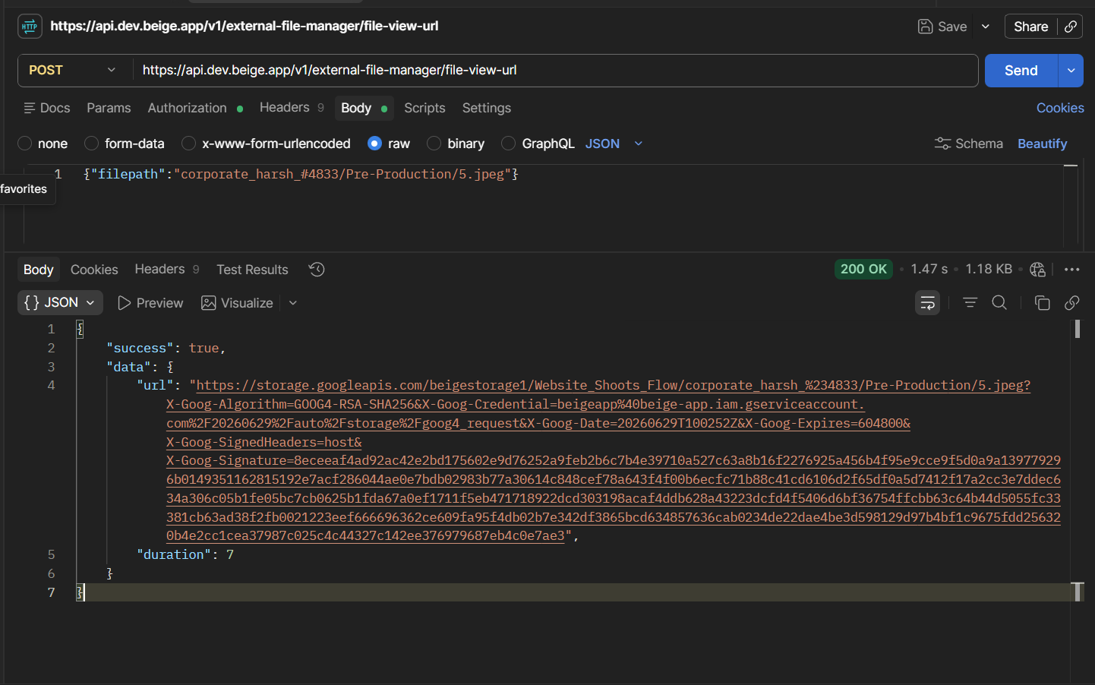

9. Download File
Returns a signed download URL.

Endpoint
POST /external-file-manager/file-download-url

Request
{
"filepath": "corporate_neha_#1273/Post-Production/Final Deliverables/5.jpeg"
}
App Res:
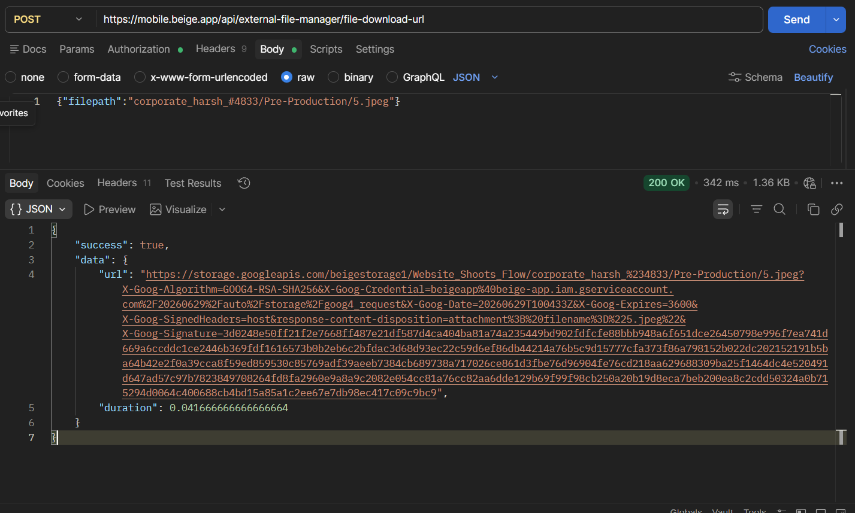
Web Res:
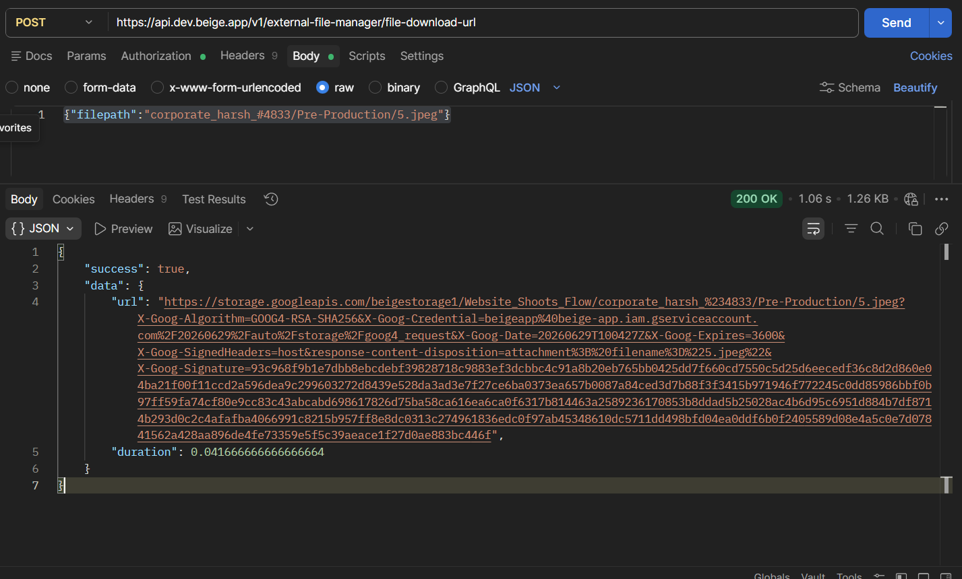

10. Delete File or Folder
Deletes a file or folder.

Endpoint
POST /external-file-manager/delete

Request
{
"filepath": "corporate_neha_#1273/Post-Production/Final Deliverables/5.jpeg"
}
App Res:
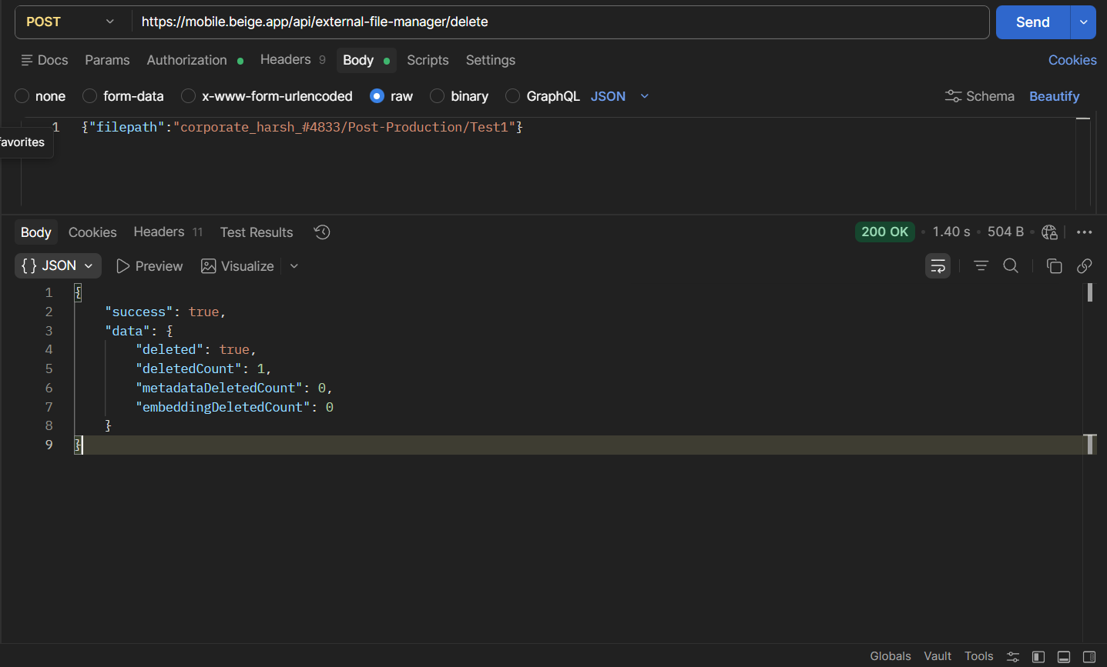

Web Res:
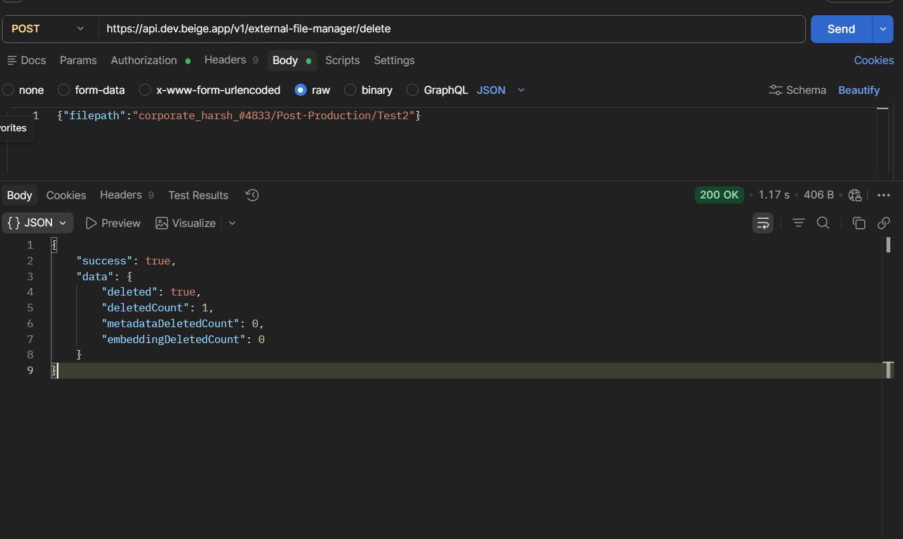

Delete Folder Example
{
"filepath": "Event - testing/"
}

11. Send Files For Edits
Moves files into the Selected for Edits folder.

Endpoint
POST /external-file-manager/copy-files

Request
{
"externalId": "1273",
"phase": "post",
"targetPath": "Edits/Selected for Edits",
"sourcePaths": [
"corporate_neha_#1273/Post-Production/Raw Footage/5.jpeg"
]
}
App Response:
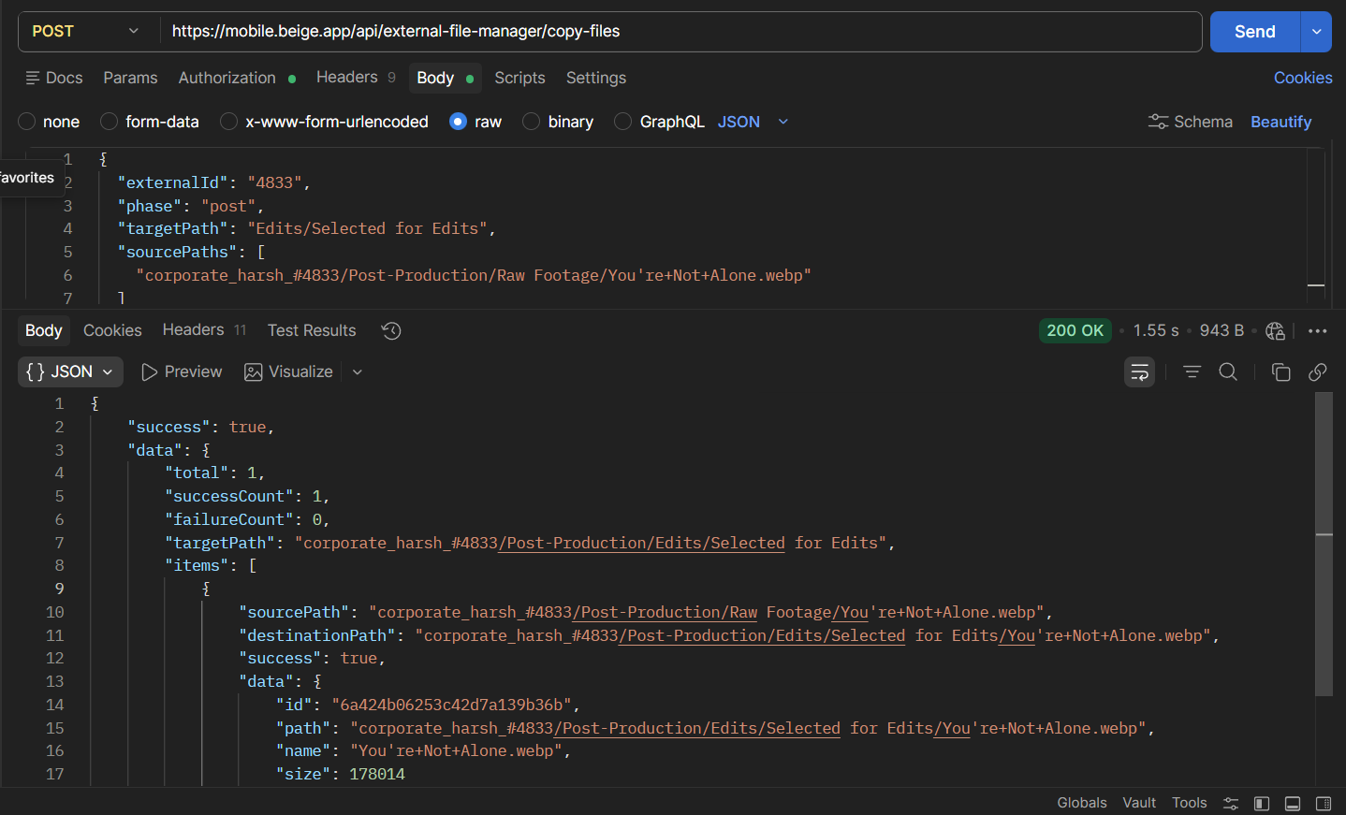
Web Response:
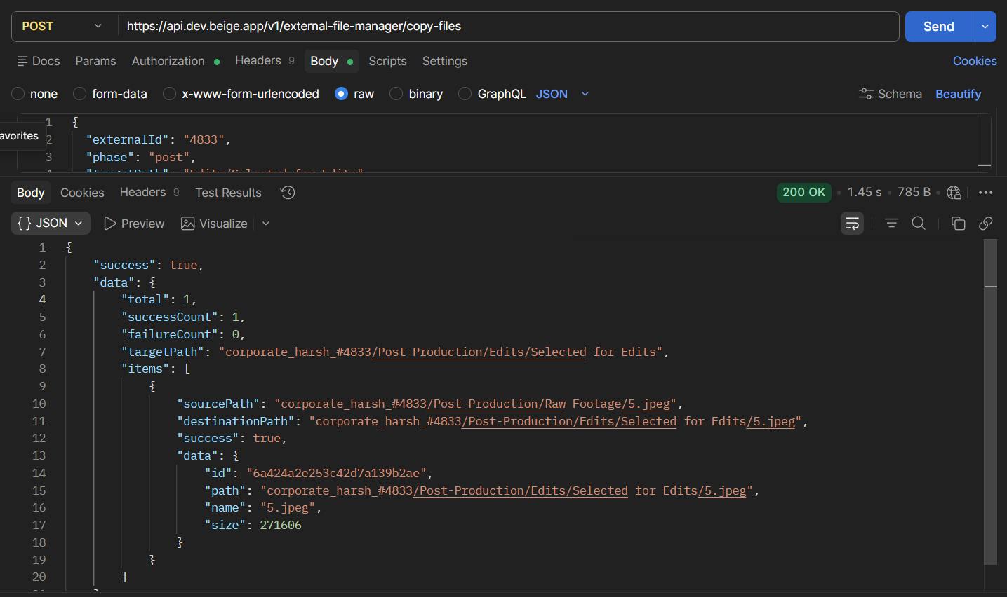

Notifications
Email sent to Admin
Email sent to Creative Partner

12. Revision Workflow

Create Version Folder
POST /external-file-manager/folder

Request
{
"externalId": "1273",
"folderName": "Version1",
"phase": "post",
"path": "Edits/Revisions"
}
Web Res:
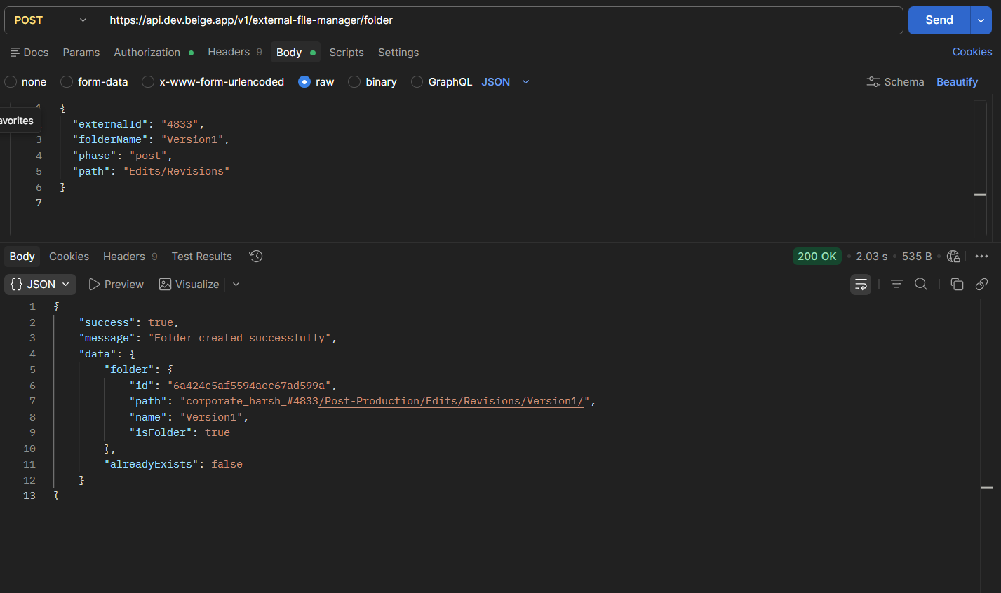

App Res:
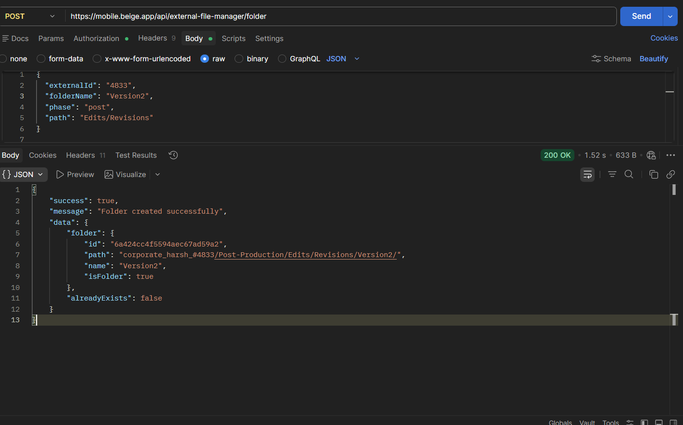

Upload Revision Files
POST /external-file-manager/upload-policies/batch

Request Revision
POST /external-file-manager/revision-file/review

Request
{
"externalId": "1273",
"filepath": "corporate_neha_#1273/Post-Production/Edits/Revisions/Version1/5.jpeg",
"action": "request_revision"
}
App Response:
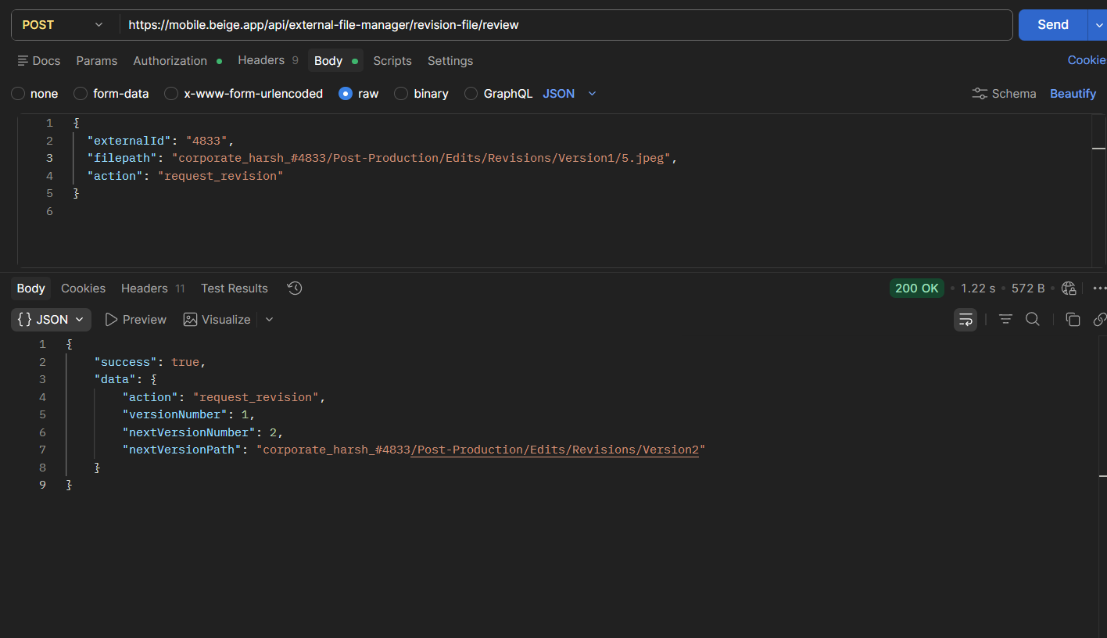

Web Response:
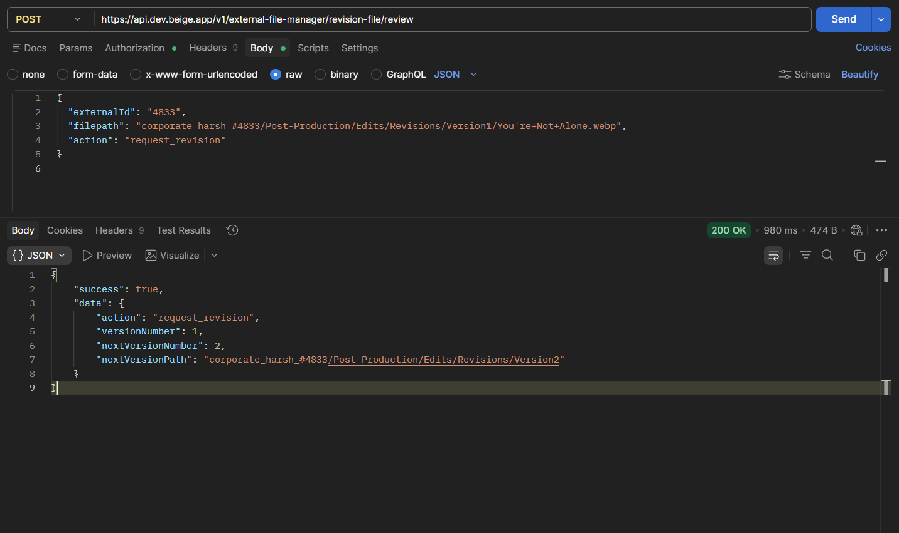

Approve Revision
{
"externalId": "1273",
"filepath": "corporate_neha_#1273/Post-Production/Edits/Revisions/Version1/5.jpeg",
"action": "approve"
}

App Response:
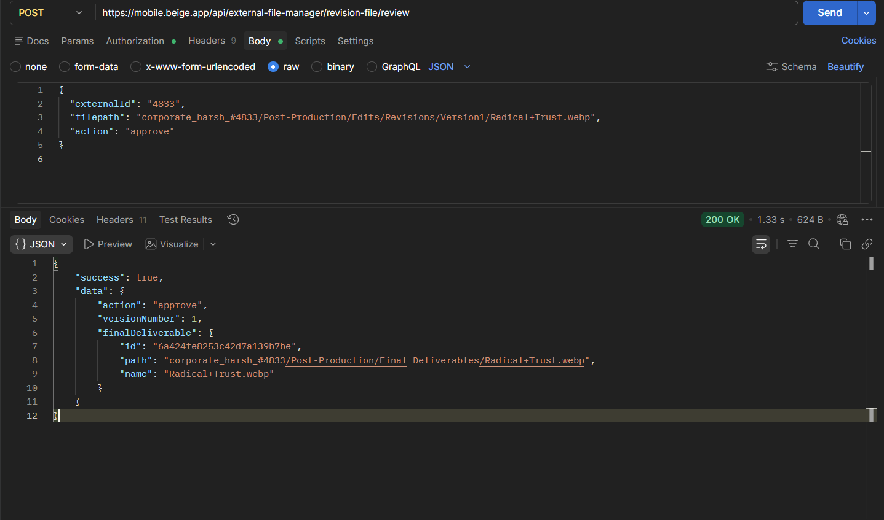

Web Response:
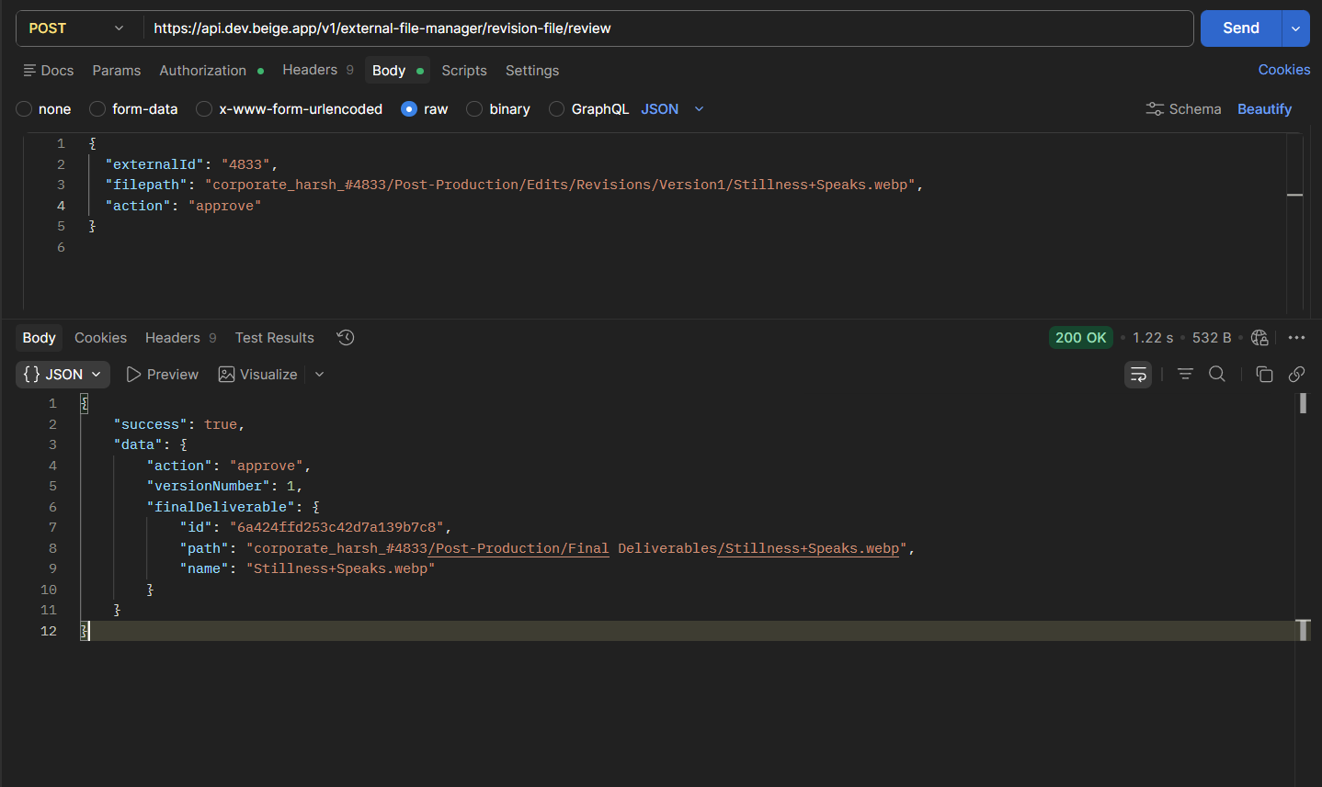

Allowed Actions
Value | Description
approve | Approve file
request_revision | Request changes

13. Comments API

Add Comment

Endpoint
POST /comments

Request
{
"fileMetaId": "corporate_neha_#1273/Post-Production/Edits/Revisions/Version2/5.jpeg",
"user_id": "281",
"comment": "Ok",
"timestamp": null
}

User Web Res:
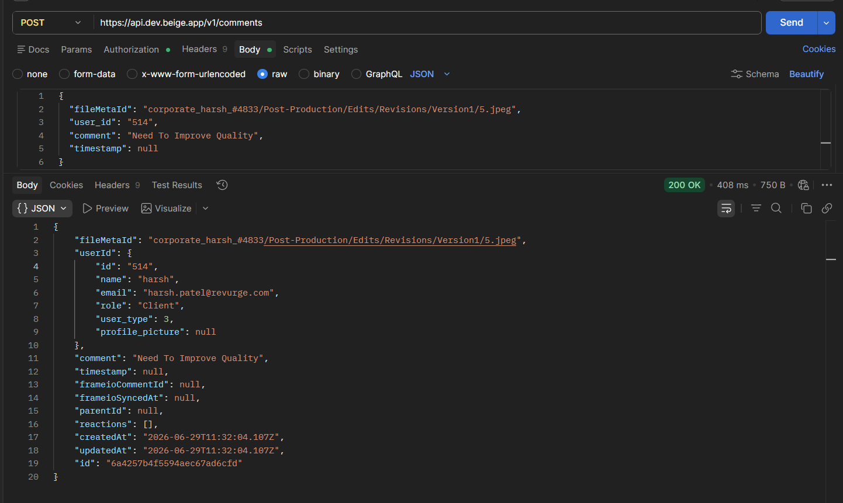

Cp App Res:
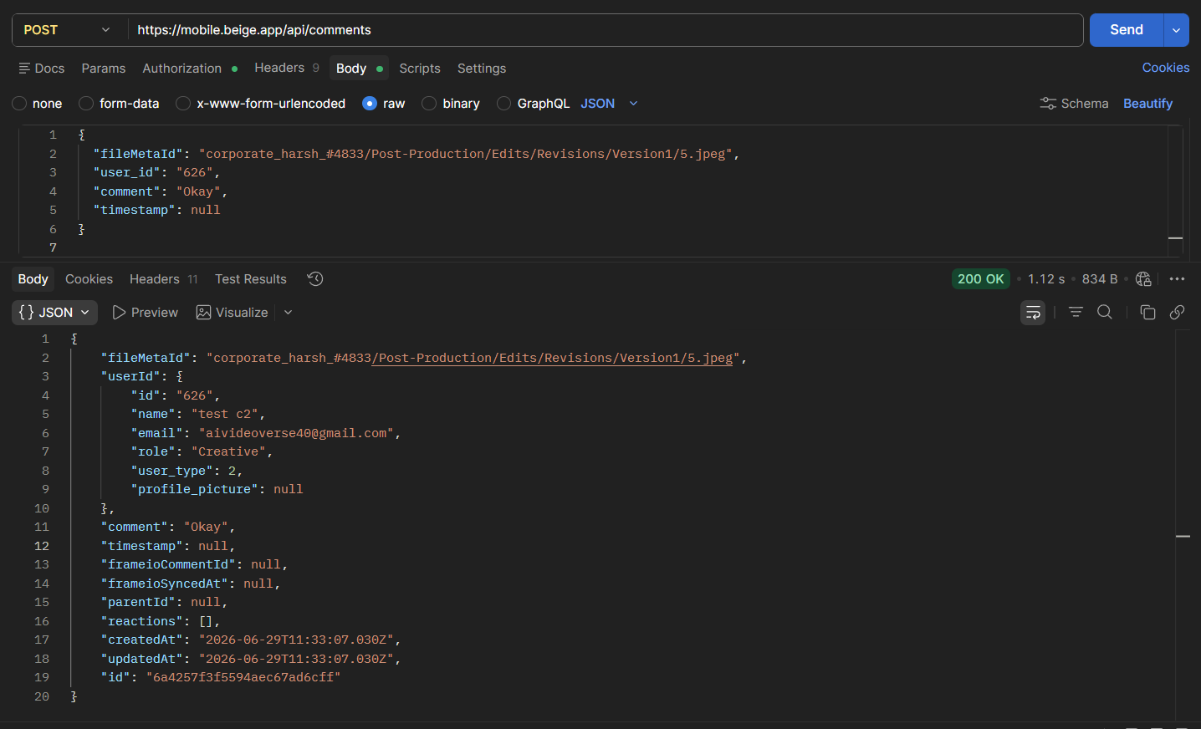

Get Comments

Endpoint
GET /comments?metaId=<fileMetaId>

App User Res:
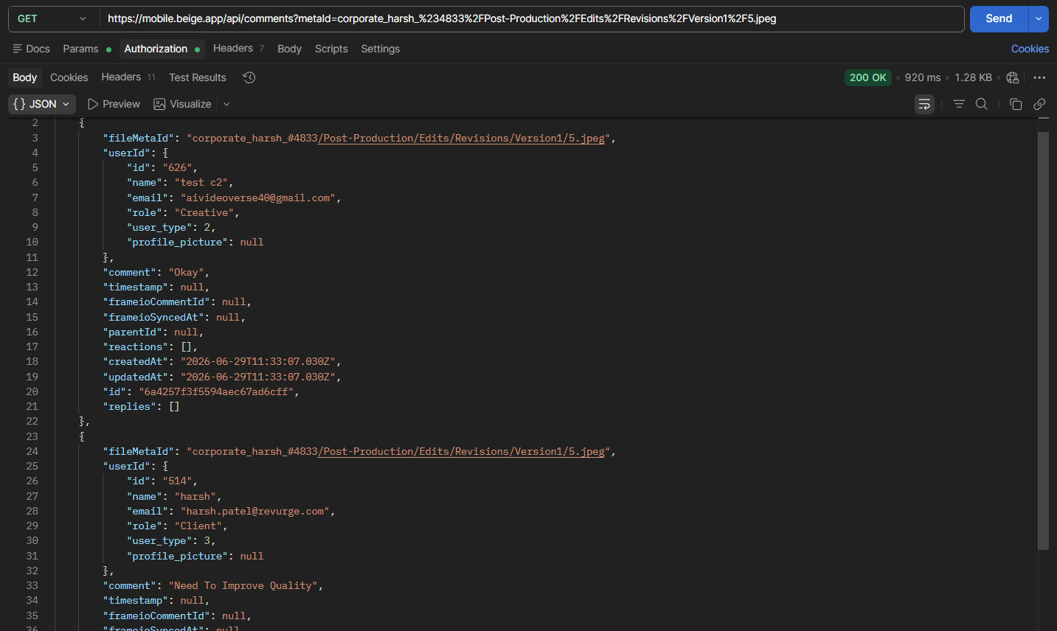

Web User Res:
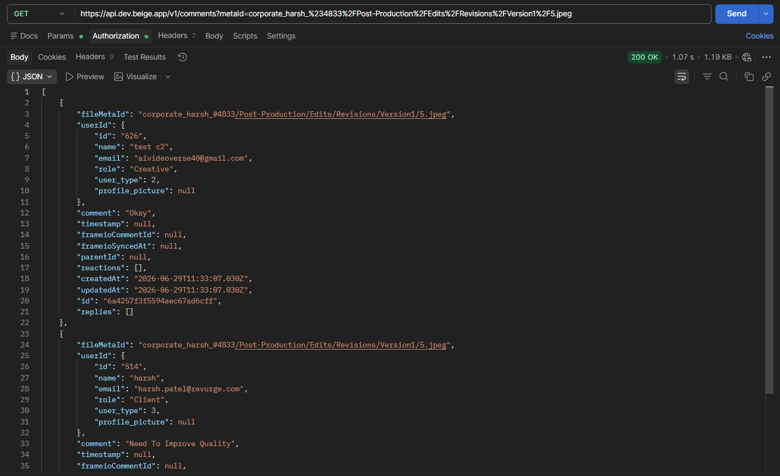

Reply To Comment

Endpoint
POST /comments/{commentId}/reply

Request
{
"user_id": "281",
"comment": "Done"
}
Web User Res:
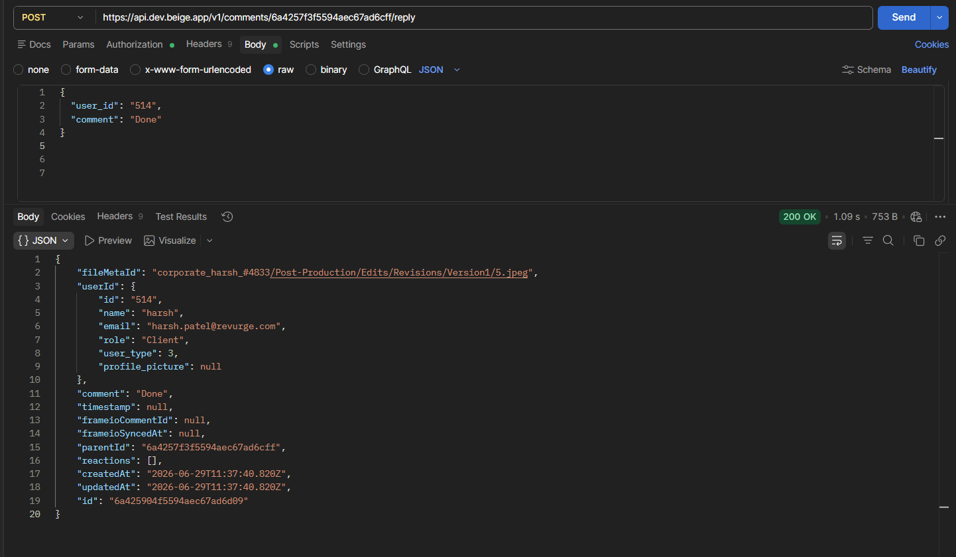

App CP Res:
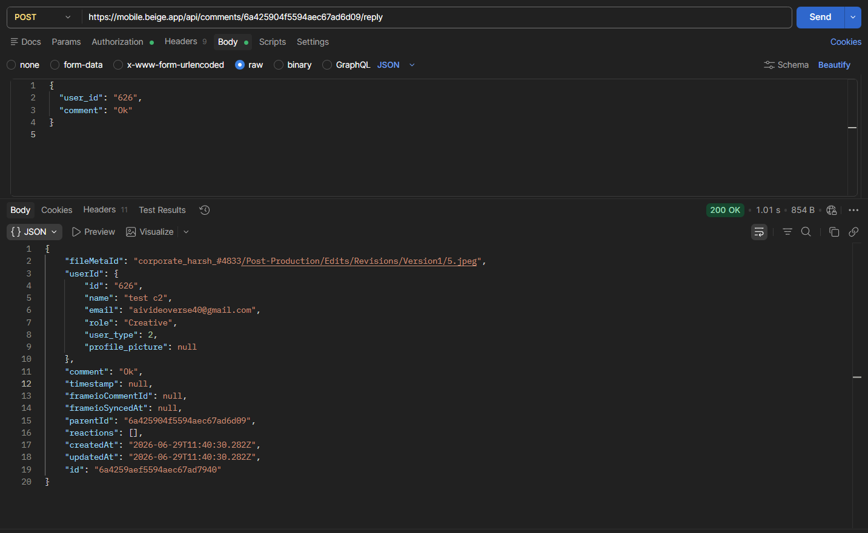

Delete Comment

Endpoint
DELETE /comments/{commentId}

Request
{
"user_id": "247"
}

14. Folder Sharing
Allows CP users to share folders externally using OTP verification.

Create Share

Endpoint
POST /external-file-manager/share

Request
{
"resourceType": "folder",
"externalId": "934",
"phase": "pre",
"email": "user@example.com",
"accessMode": "email_only",
"message": ""
}

Get Share Information
GET /external-file-manager/share

Example: GET /external-file-manager/share?resourceType=folder&externalId=4833&phase=pre

Get Access Logs
GET /external-file-manager/share/access-logs
Example: /external-file-manager/share/access-logs?resourceType=folder&externalId=4833&phase=pre

Revoke Share
DELETE /external-file-manager/share

Request
{
"shareId": 4
}

15. Request Share OTP

Endpoint
POST /external-file-manager/share/request-otp

Request
{
"shareToken": "shr_xxxxxxxxx",
"email": "user@example.com"
}

16. Verify Share OTP

Endpoint
POST /external-file-manager/share/verify-otp

Request
{
"shareToken": "shr_xxxxxxxxx",
"otp": "653431",
"email": "user@example.com"
}

Response
Returns a JWT token for accessing shared content.

17. View Shared Content

Endpoint
GET /external-file-manager/share/{shareToken}/content

Headers
Authorization: Bearer <JWT_TOKEN>

Optional Query Parameters
Parameter | Description
phase | Folder phase
path | Folder path

18. View Shared File

Endpoint
GET /external-file-manager/share/{shareToken}/view-url

Query Parameters
Parameter | Description
filepath | File path
phase | Folder phase

19. Download Shared File

Endpoint
GET /external-file-manager/share/{shareToken}/download-url

Query Parameters
Parameter | Description
filepath | File path
phase | Folder phase

20. Common Events

Create Common Event (Admin Only)

Endpoint
POST /external-file-manager/common-events

Request
{
"eventName": "testing",
"visibleUntil": "2026-06-30"
}

Get Common Events

Endpoint
GET /external-file-manager/common-events

Web CP Res:
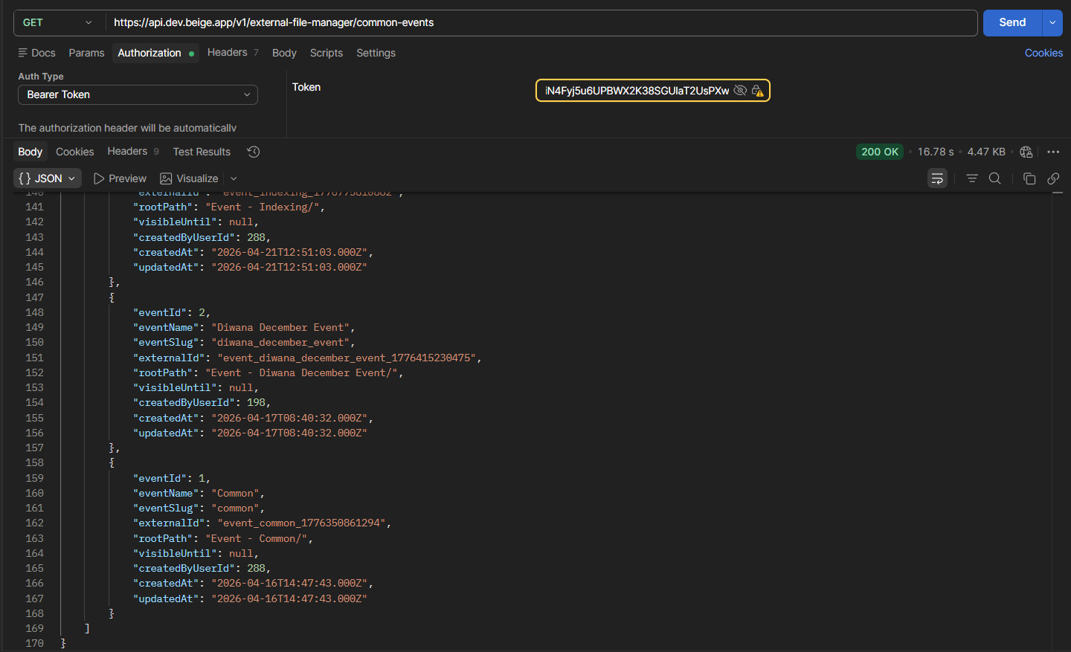

App CP Res:
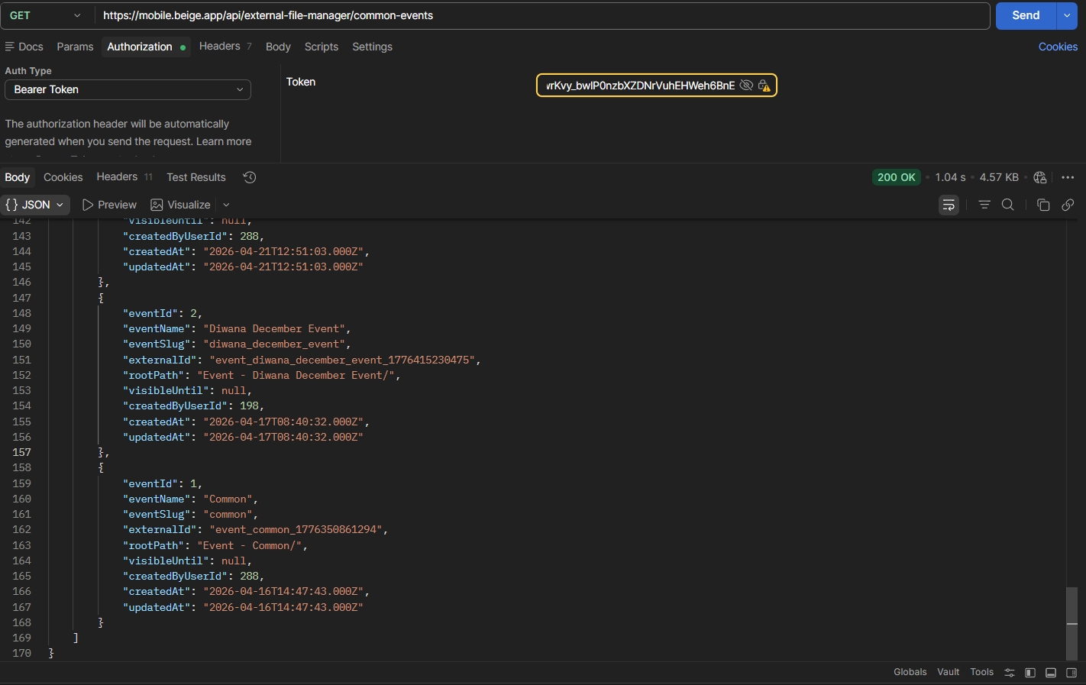

Update Common Event Visibility (Admin Only)

Endpoint
PATCH /external-file-manager/common-events/{{eventExternalId}}
{
"visibleUntil": "2026-07-15"
}

Create Creator Folder Inside Common Event

Endpoint
POST /external-file-manager/common-events/{{eventExternalId}}/creator-folder
{
"folderName": "Event Test",
"path": ""
}

App CP Res:
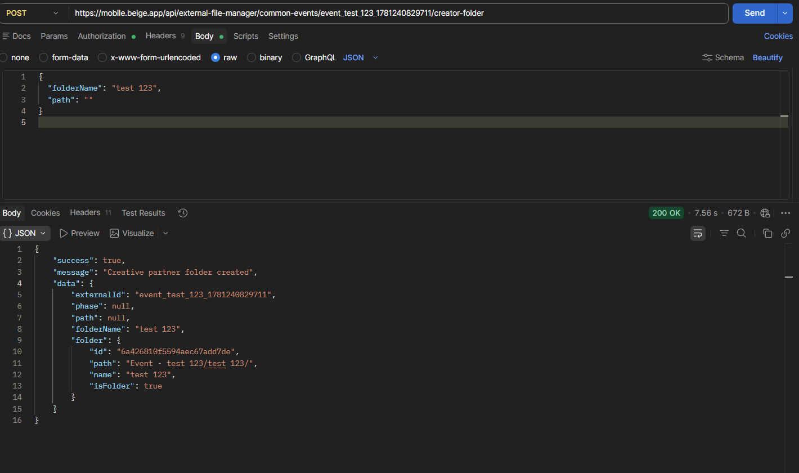

Web CP Res:
